Assignment - 3: State Space Puzzle

Due Date: 11:59 PM, April 12th (Monday Night)

Total Marks: 20 marks

**Problem statement:** Find all the solutions to A-B-C jug problem.

You are given 3 jugs A, B, C of capacities a, b, c litres respectively.

The initial state/initial volumes of water in the jugs are X, Y, Z.

Your goal is to get to a final state of P, Q, R litres.

There are no markings on the jugs (you can’t just measure off litres directly).

You may pour from a jug to any other jug (you have to transfer from one jug to another until either one jug becomes empty or the other full). You cannot waste water. The total amount of water in the entire system must be the same as the initial.

**Note:** You can use the skeletal structure of the code that Sir has given.

**Input format:**

a b c

X Y Z

P Q R

Sample input for 8-5-3 jug problem (sample input file is available in the folder):



**Output format:**

Print all the solutions for the given problem. (For example, if there are 3 solutions)

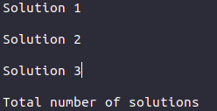

Each solution starts with the move performed on start state X Y Z followed by all the moves to be performed to get the intermediate states in every line until we reach the move to be performed to get the final state P Q R.

In the end, the total number of possible solutions is also printed.

Examples of moves that can be performed:

Example 1: Water from jug A is poured into jug C.

A C

Let us say before the above move was performed, the capacities in each jug A, B, C were 8, 0, 0 litres respectively. After water from jug A is poured into jug C, the capacities of the jug now become 5, 0, 3 litres in each jug A, B, C respectively.

Example 2: Water from jug C is poured into jug B.

C B

Let us say before the above move was performed, the capacities in each jug A, B, C were 5, 0, 3 litres respectively. After water from jug C is poured into jug B, the capacities of the jug now become 5, 3, 0 litres in each jug A, B, C respectively.

An example of two such solutions for the 8-5-3 jug problem with 8-0-0 as the initial state and 4-4-0 as the final state is (note that this should give you an idea of the output format):



**Note:**

To make sure your outputs are the same, the order of the 6 transitions has to be this (so make appropriate adjustments to the callback array):

A->B

A->C

B->A

B->C

C->A

C->B

Here is how the capacities of each jug A, B, C would look like if the following moves/transitions were to be performed. (Mentioned only for better understanding, taking an example for only one solution. The output format should follow the file sample_output.txt. Any deviation will result in zero marks).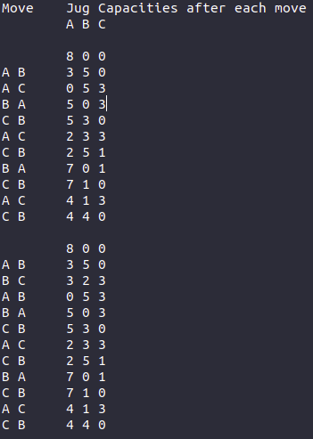

Additional points to keep in mind:

* You may either implement your solutions using iterative backtracking or recursive backtracking but, you must implement your solutions using call back arrays. Ensure that the same order of the transitions is performed as mentioned above.
* Inputs & Outputs will be terminal-based. So, please use stdin & stout for taking inputs & displaying outputs, you need not read or write from files.
* Test-cases will always consist of 3 jugs, however, the sizes and capacities of each jug might vary in different test-cases.
* All inputs that are given shall be valid (i.e. no test-cases where capacities exceed the size of jug shall be given).
* We will not be checking for test-cases where there are no solutions.
* We will also not be checking for test-cases with the same start & end states.
* Sample input & output files have been provided for a small test case. Please ensure to print all the solutions along with the total number of solutions for any given test-case. Marks will also be given to check the total number of solutions for a given test case.

**Deliverables:**

For this assignment, you need to submit four files: client, header, and implementation, and readme.

A3_client_<SRN>.c

A3_header_<SRN>.h

A3_impl_<SRN>.c

A3_README_<SRN>.txt: Should contain the following:

* How to compile your code.
* Data structures used.
* The logic behind your implementation.
* Key takeaways from this assignment.

You can ask your doubts at [Doubt Clarifications](https://docs.google.com/spreadsheets/d/1pMnjK6HXHZYLRXddQPp3yp0hkXvw0saxsXYrKcmJNu0/edit?usp=sharing)  (Use Assignment 3 Sheet)

**Submission link:** <https://forms.gle/69UMHrkPAfsbqjJi8>

**Any cases of plagiarism will be dealt with seriously. DO NOT COPY/SHARE CODE. Do not take code from your peers or seniors or from online sources.**

**If you believe you can get away after plagiarising, think again.**